Balance Sheet Questions

Questions
Assets | Liabilities
Required Reserves  10,000  Excess Reserves  5000  Loans  85,000 | Demand Deposits  100,000
- Use information in the table above to answer the question.
Show the new amounts in the balance sheets if the customer withdraws $1000.

Assets | Liabilities
Required Reserves  5,000  Excess Reserves  7500  Loans  37,500 | Demand Deposits  50,000
- Use information in the table above to answer the question.
Show the new amounts in the balance sheets if the RRR is changed from 10% to 20%.

Assets | Liabilities
Required Reserves  4,000  Excess Reserves  2000  Loans  34,000 | Demand Deposits  40,000
- Use information in the table above to answer the question.
Show the new amounts in the balance sheets if a customer deposits an extra $2000.

Assets | Liabilities
Required Reserves  25,000  Excess Reserves  30,000  Loans  95,000 | Demand Deposits  150,000
- Use information in the table above to answer the question.
Show the new amounts in the balance sheets if the bank decides to create the maximum amount of loans it can create.

Assets | Liabilities
Required Reserves  2,000  Excess Reserves  3000  Loans  5000 | Demand Deposits  10,000
- Use information in the table above to answer the question.
Show the new amounts in the balance sheets if the RRR changes from 20% to 15%.

Assets | Liabilities
Required Reserves  5,000  Excess Reserves  25000  Loans  20,000 | Demand Deposits  50,000
- Use information in the table above to answer the question.
Show the new amounts in the balance sheets if the RRR is changed from 10% to 20%.

Assets | Liabilities
Required Reserves  5,000  Excess Reserves  25000  Loans  20,000 | Demand Deposits  50,000
- Use information in the table above to answer the question.
Show the new amounts in the balance sheets if the bank decides to create another $5000 of loans.

Assets | Liabilities
Required Reserves  1500  Excess Reserves  1500  Loans  7000 | Demand Deposits  10,000
- Use information in the table above to answer the question.
Show the new amounts in the balance sheets if a customer deposits an additional $500.
Assets | Liabilities
Required Reserves  4,000  Excess Reserves  2000  Loans  34,000 | Demand Deposits  40,000
- Use information in the table above to answer the question.
Show the new amounts in the balance sheets if the customer withdraws $5000.
Assets | Liabilities
Required Reserves  6000  Excess Reserves  14,000  Loans  40,000 | Demand Deposits  60,000
- Use information in the table above to answer the question.
Show the new amounts in the balance sheets if the customer withdraws $10,000.

Answers
1.
Assets | Liabilities
Required Reserves  10,000 – 100 = 9900  Excess Reserves  5000 – 900 = 4100  Loans  85,000 | Demand Deposits  100,000 – 1000 = 99000

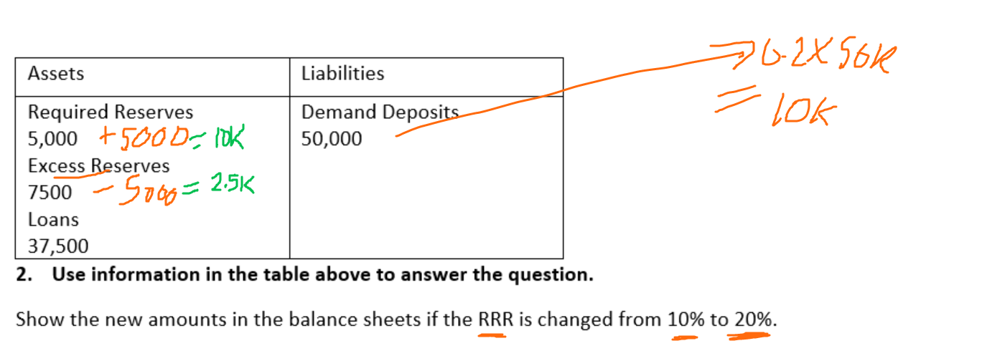
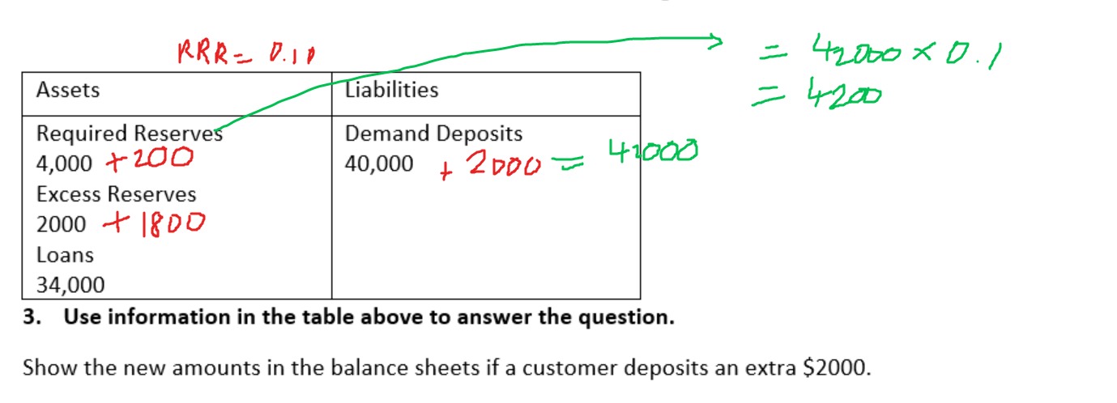
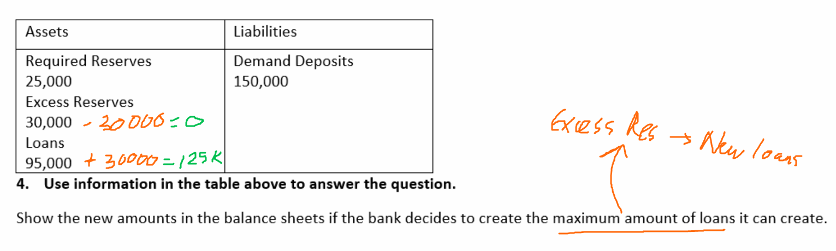
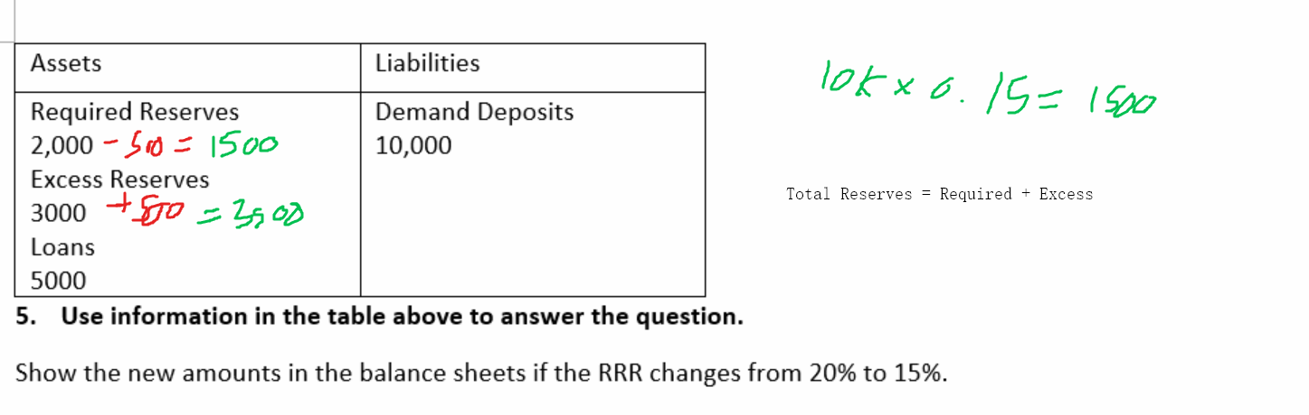
6.
Assets | Liabilities
Required Reserves  5,000 + 5000 = 10,000  Excess Reserves  25000 – 5000 = 20,000  Loans  20,000 | Demand Deposits  50,000

7.
Assets | Liabilities
Required Reserves  5,000  Excess Reserves  25000-5000 = 20000  Loans  20,000 + 5000 = 25000 | Demand Deposits  50,000

8.
Assets | Liabilities
Required Reserves  1500+75 = 1575  Excess Reserves  1500+425 = 1925  Loans  7000 | Demand Deposits  10,000 + 500 = 10,500

9.
Assets | Liabilities
Required Reserves  4,000-1000 = 3000  Excess Reserves  2000 – 2000 = 0  Loans  34,000  Bank still needs to find another 2000 to cover the decrease in deposits. Could borrow from another bank. | Demand Deposits  40,000 – 5000 = 35000

10.
Assets | Liabilities
Required Reserves  6000 – 1000 = 5000  Excess Reserves  14,000 – 9000 = 5000  Loans  40,000 | Demand Deposits  60,000-10,000 = 50,000

